***SQL 99***

1. ***Drill Down on product to find description, type , total sales amount through year, quarter and month***

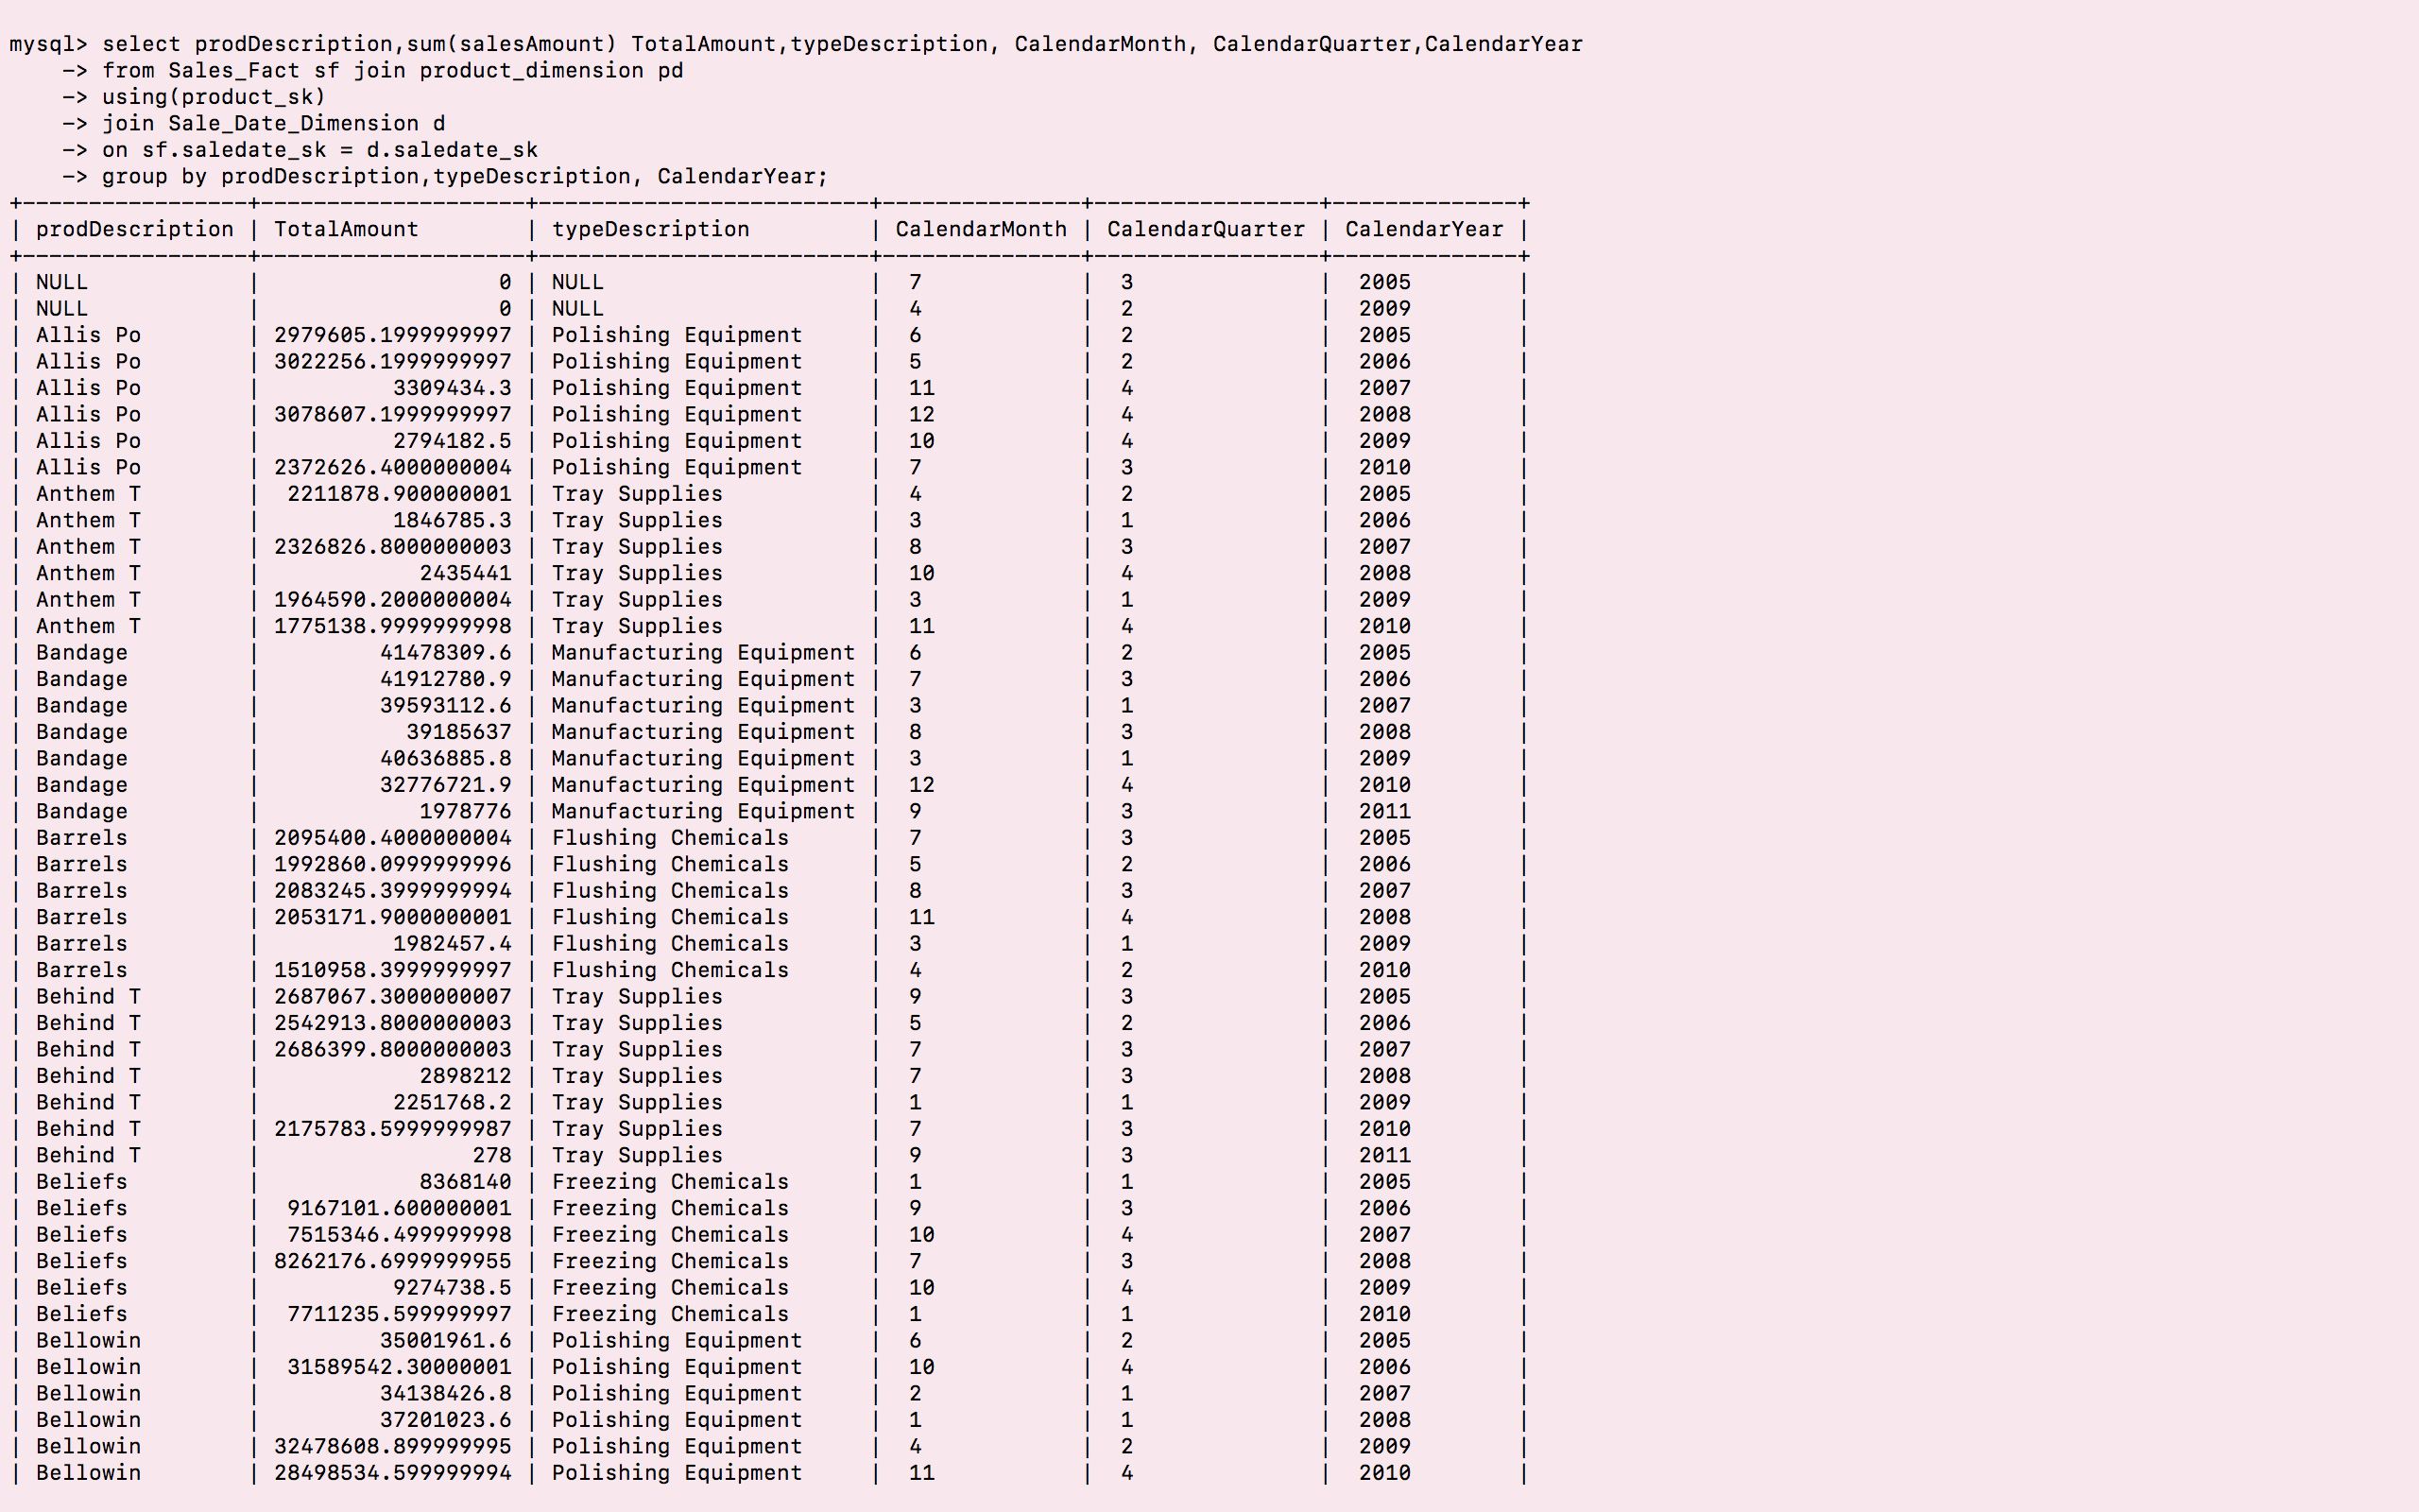

1. ***Slice to find sales by type of customer, by state, by product type and business unit***

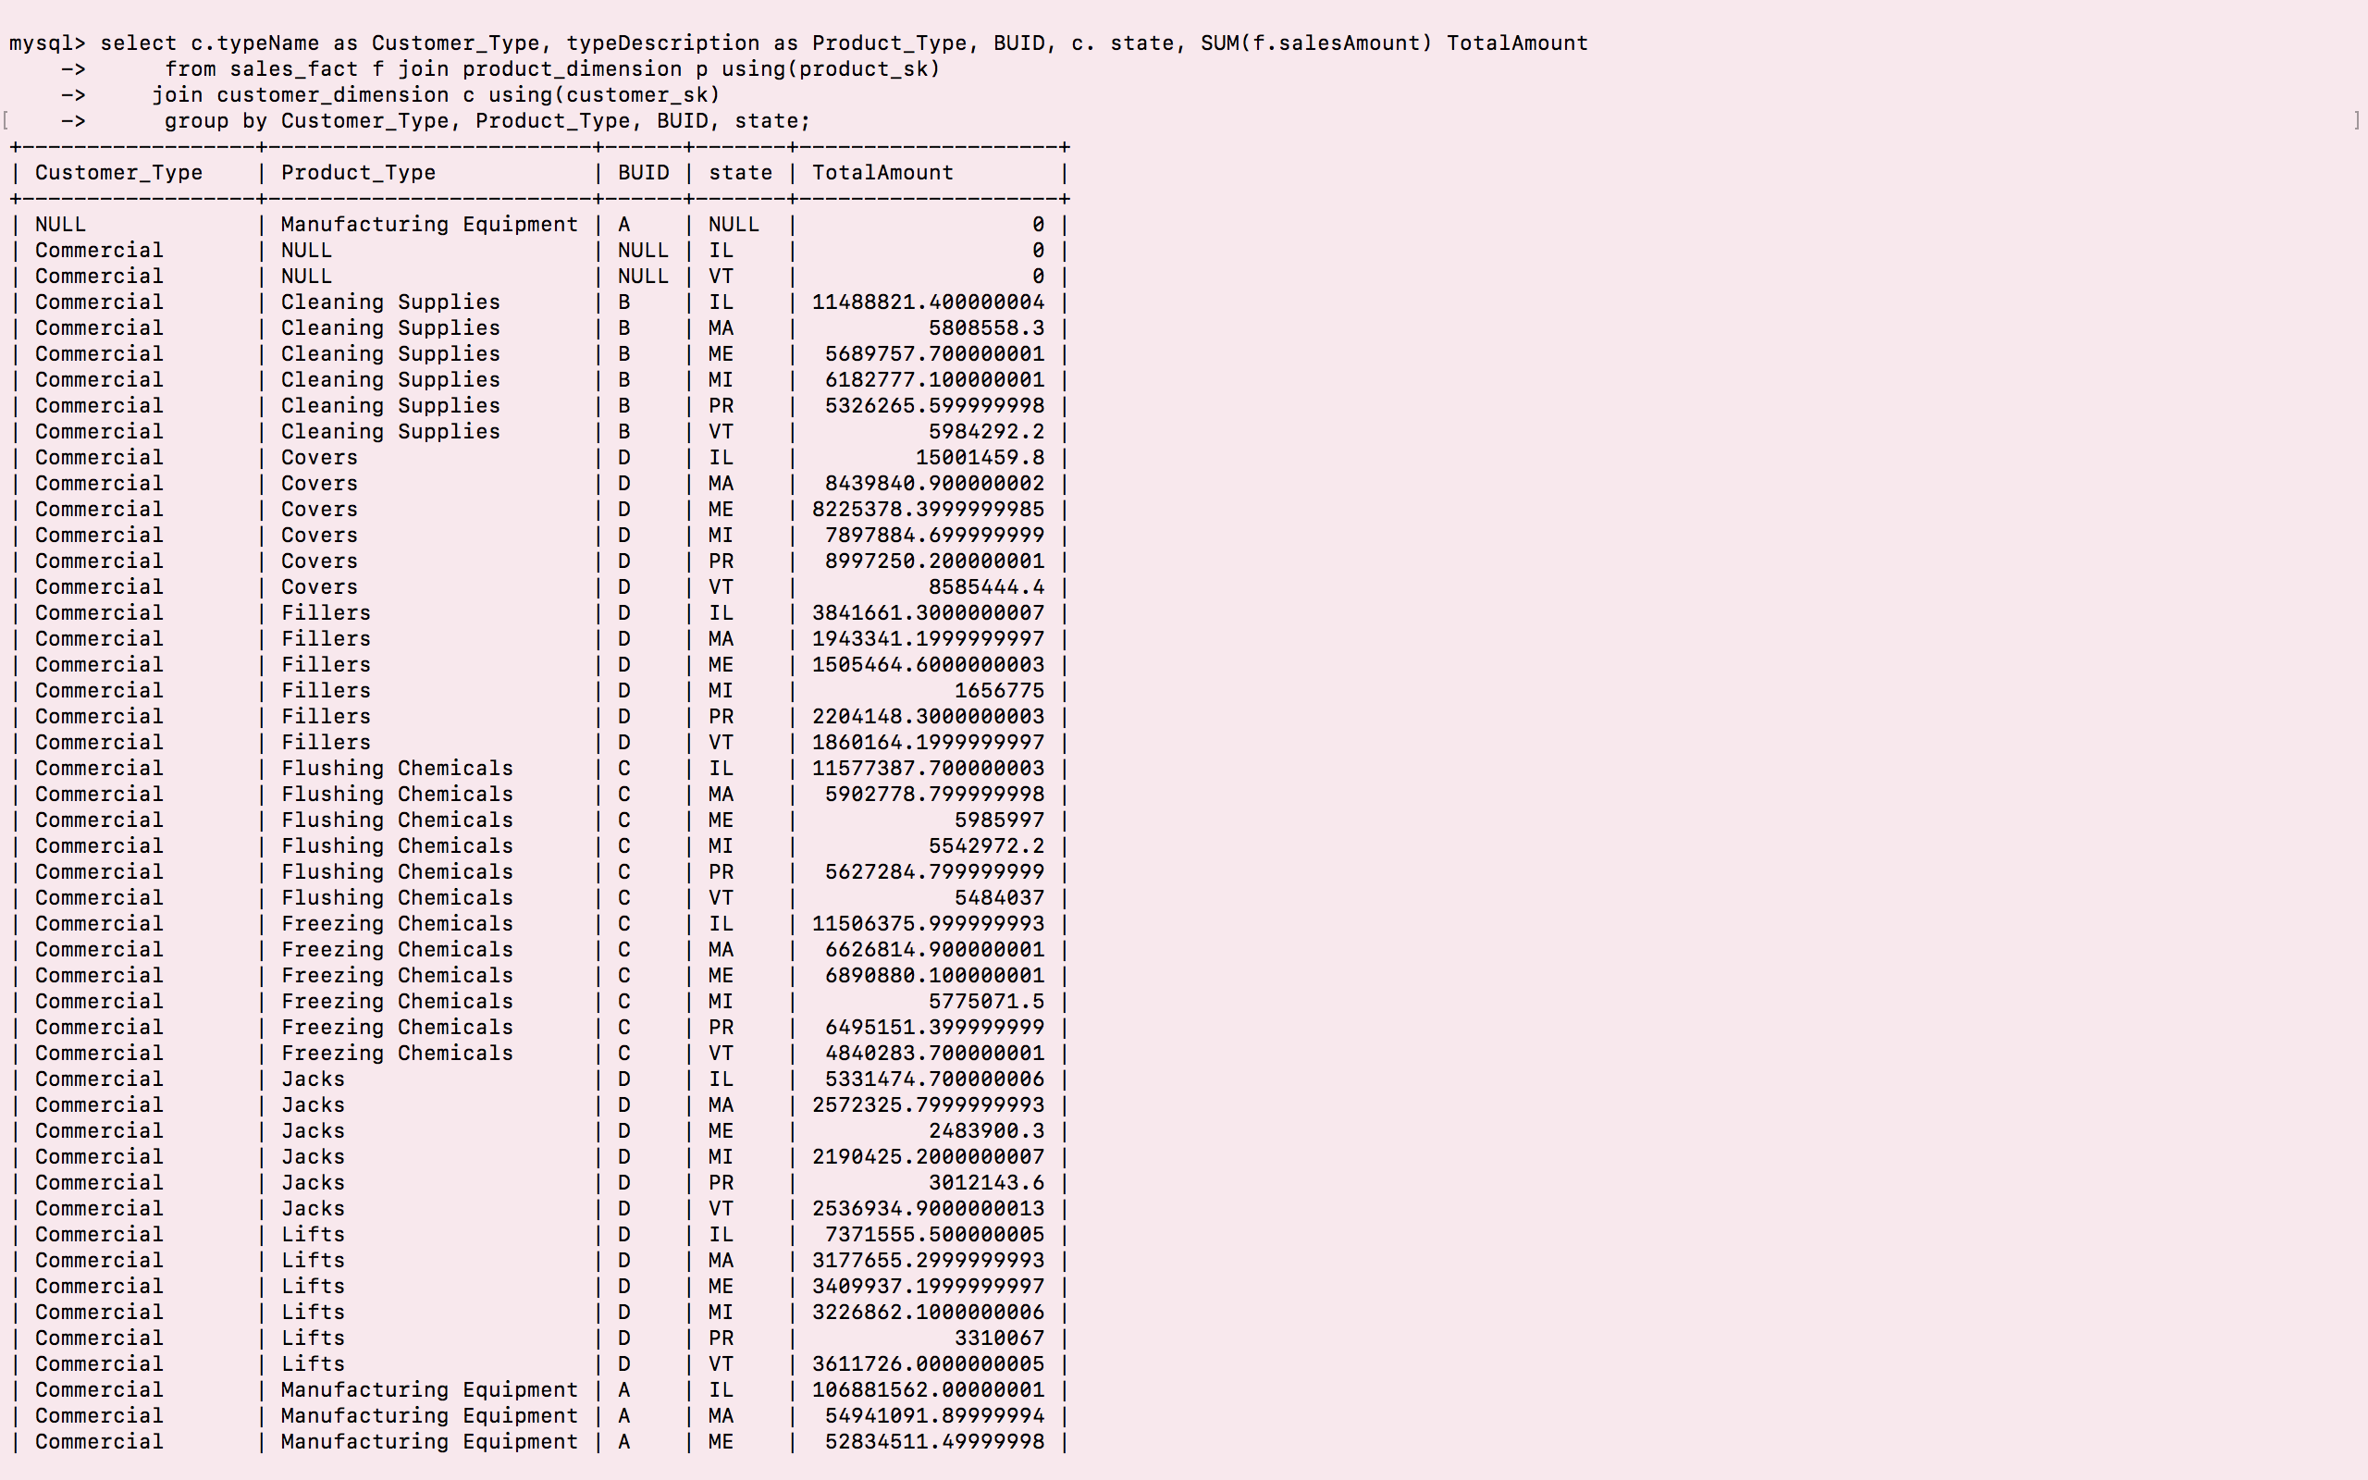

1. **Rank to find top customer**

